PERCENTAGE INCREMENTAL ACADEMIC GROWTH OF THE STUDENTS FOR BATCH
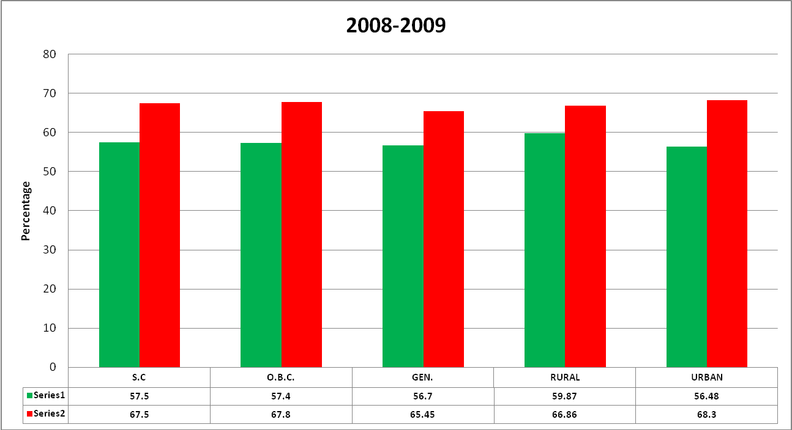

PERCENTAGE INCREMENTAL ACADEMIC GROWTH OF THE STUDENTS FOR BATCH
