ALUMNI FEEDBACK FROM B.Ed. STUDENT`S OF BRAHASPATI MAHILA MAHAVIDYALAYA
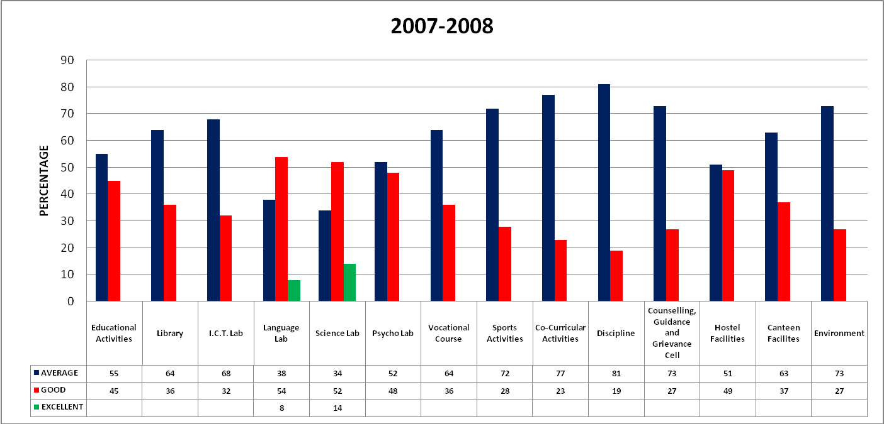

ALUMNI FEEDBACK FROM B.Ed. STUDENT`S OF BRAHASPATI MAHILA MAHAVIDYALAYA
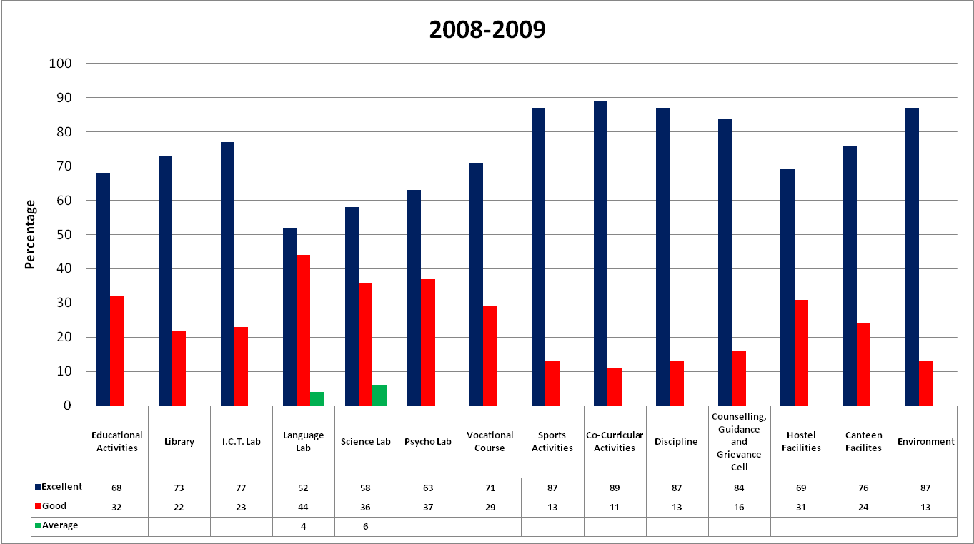

ALUMNI FEEDBACK FROM B.Ed. STUDENT`S OF BRAHASPATI MAHILA MAHAVIDYALAYA
